First page of power BI, which is called “CANAVS”.

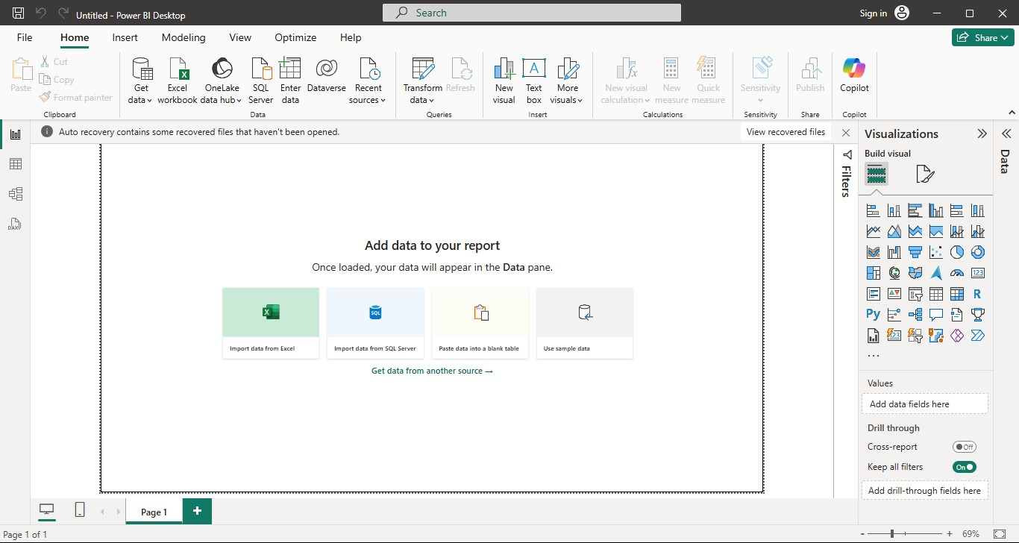

To upload the data click on Get Dataselect the type of the file.

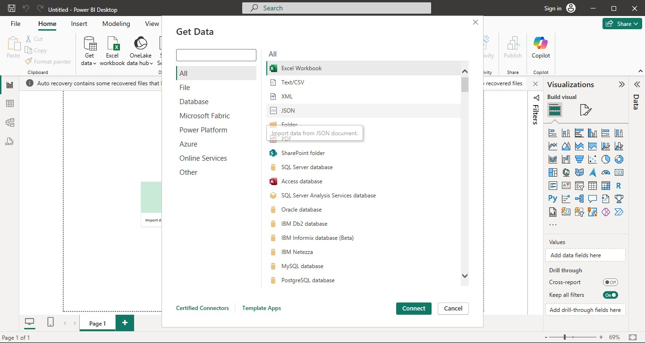

After selecting the type of the file, selecting the file that need to upload.

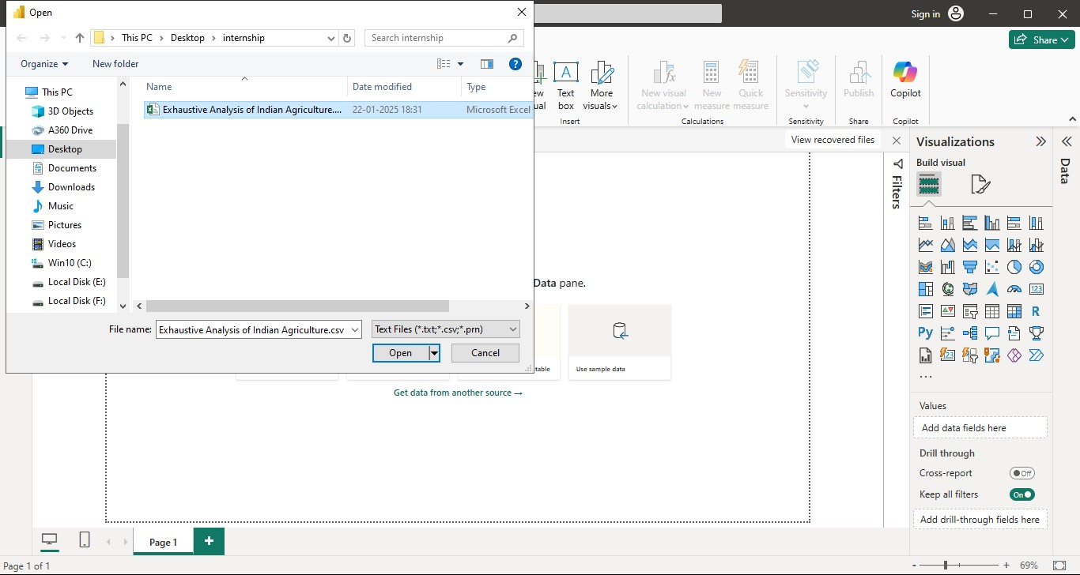

The below image shows that data .The data is about “Exhaustive Analysis of the Agriculture”.

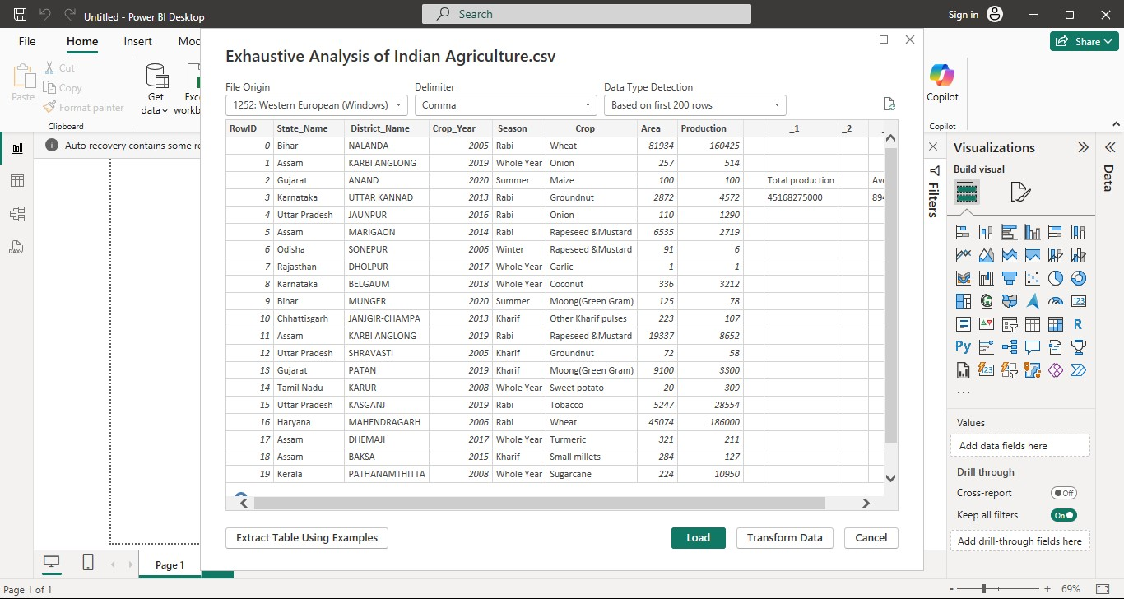

In the above image there are two options Load and Transform**.** By clicking onLoadit shows below image.

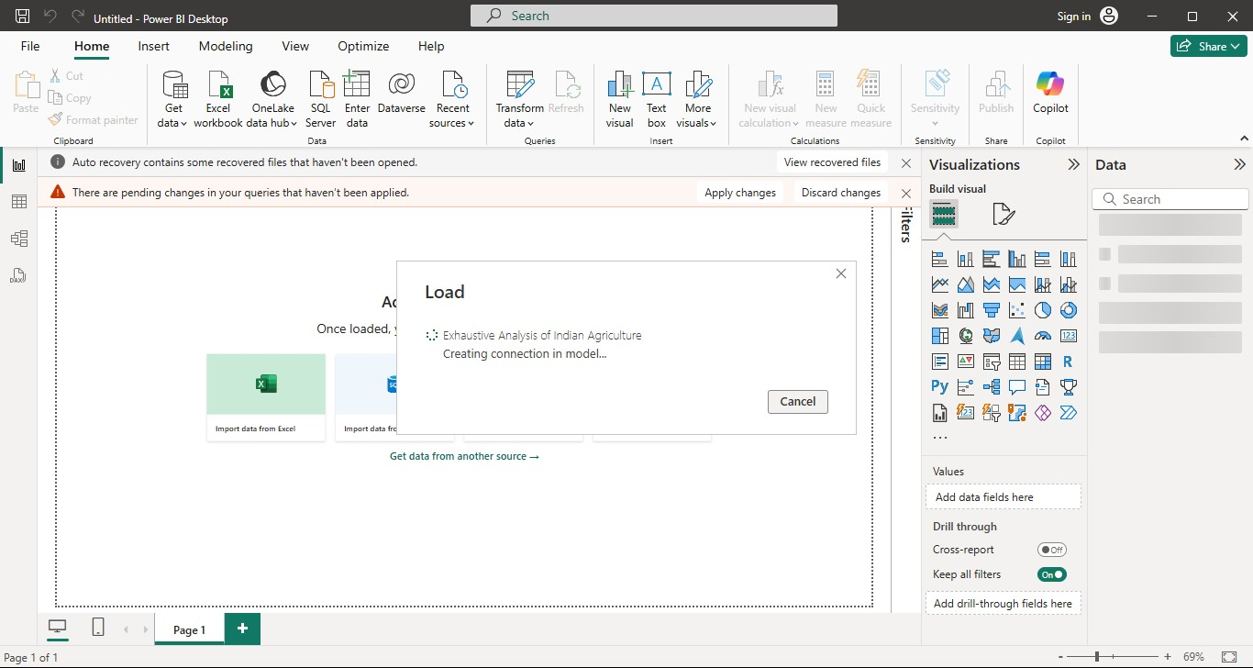

After Loadoperataion the file is appeared on right side i.e. Data**.**

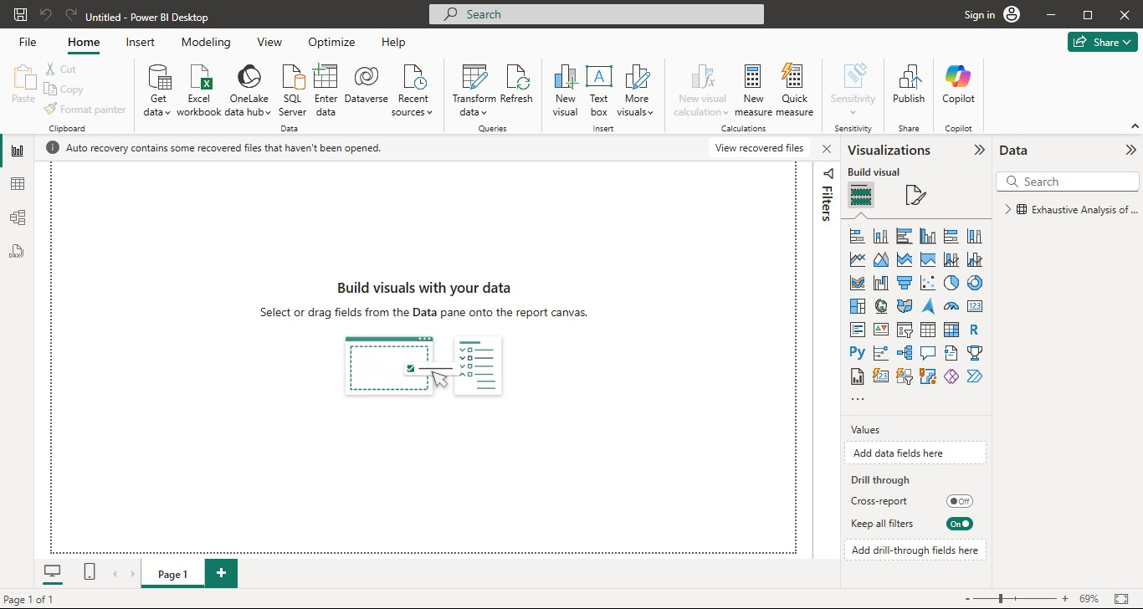

After Loadoperation ,clicking on Transformin above image it goes to Power Query Editorandshows below image.

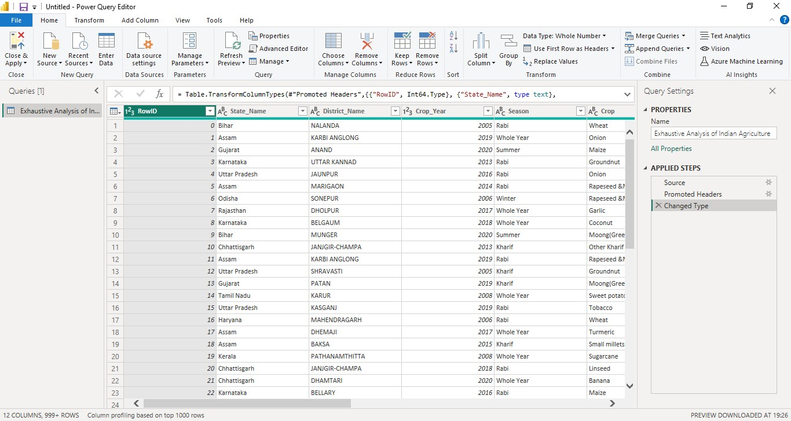

To know the errors or empty cells ,click on view then column quality itshows below image.

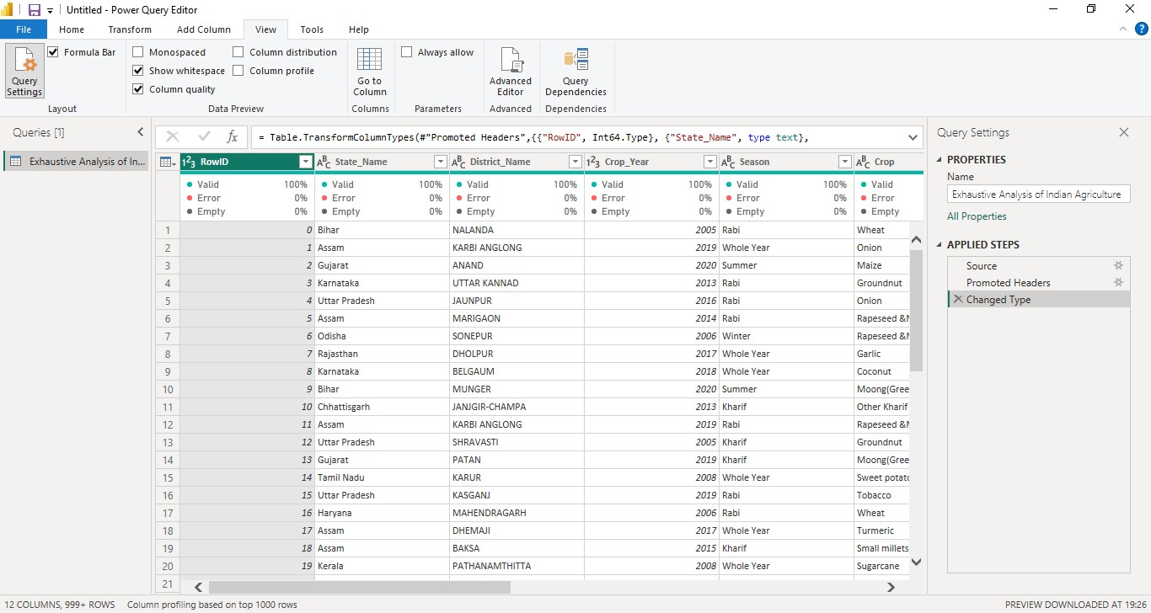

By selecting the three columns to delete ,click onRemove columns and it shows on right side in Applied Steps**.**

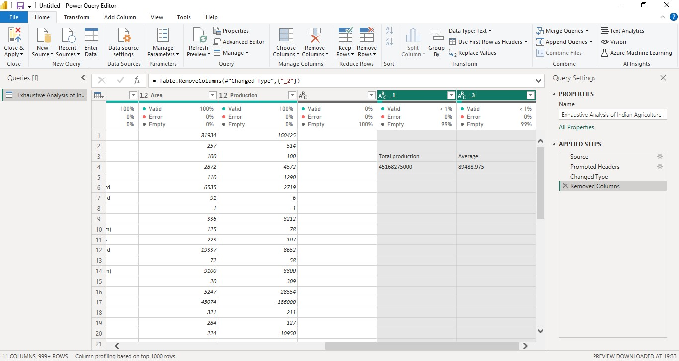

After Deleting the un-necessasry columns. To go to Power BI Desktop click on Close &Applyon left side and select Close & Apply**.**

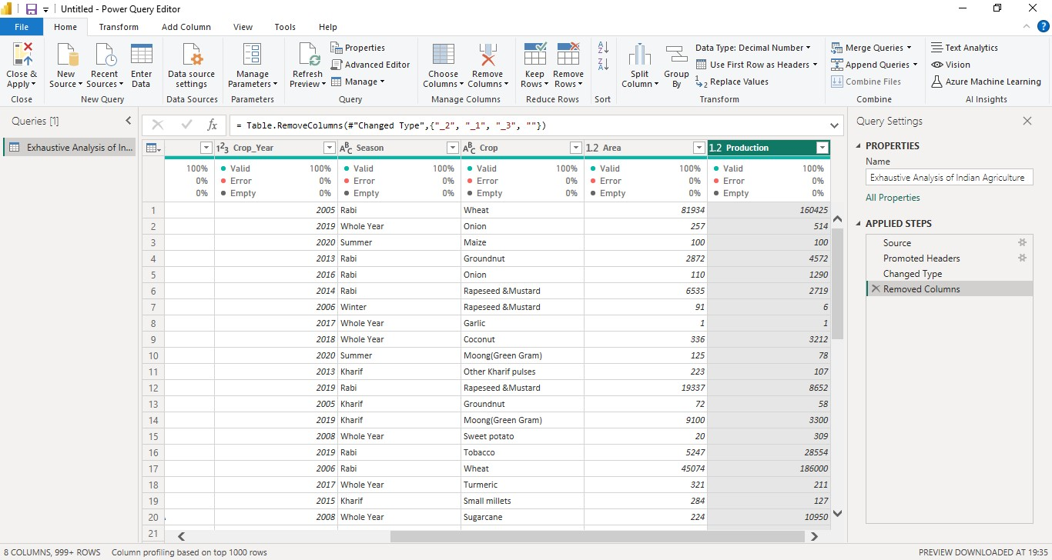

The below image shows Table View**.**

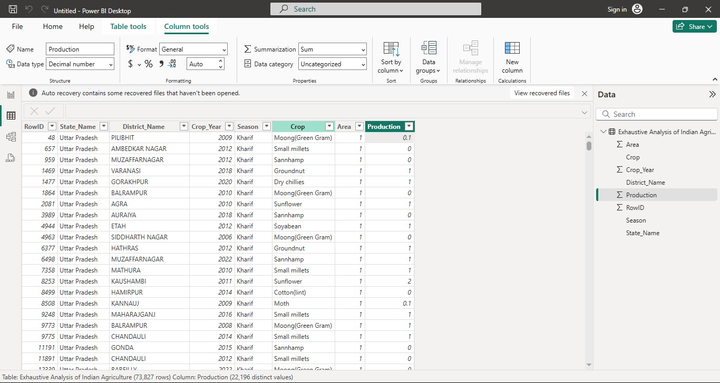

The below image shows Model View**.**

